### Project Report

1. **INTRODUCTION**

### Overview

Clinic, an organized medical service offering diagnostic, therapeutic, or preventive outpatient services. Often, the term covers an entire medical teaching centre, including the hospital and the outpatient facilities. The medical care offered by a clinic may or may not be connected with a hospital .

## Purpose

The organization of a hospital clinic in general follows that of the inpatient facilities. Hospital clinics are primarily concerned with acute diseases, and the physicians in the clinics are usually the same physicians who treat inpatients in the hospital

1. **Problems Definition & Design Thinking**
   1. **Empathy Map**

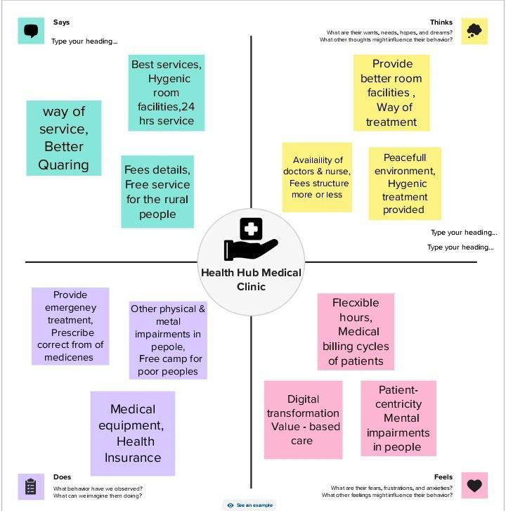

* 1. 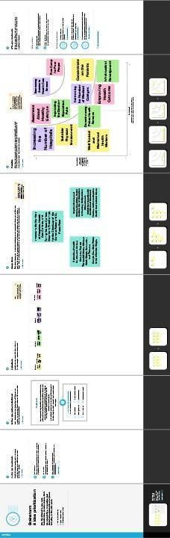**Ideation & Brainstorming Map**

1. **Result**

* Profit & Loss Account

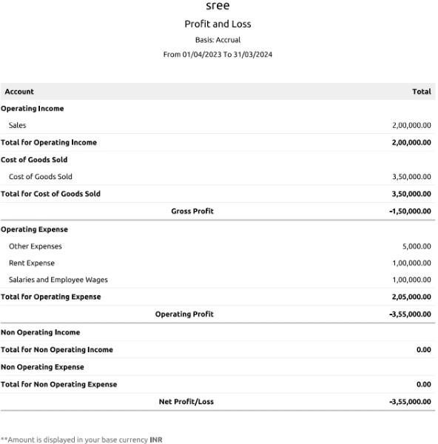

## Balance sheet

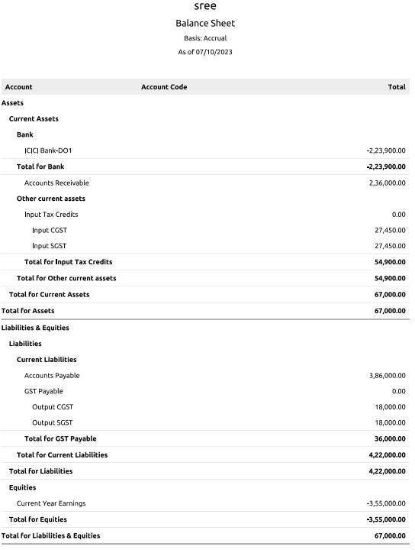

### ADVANTAGES & DISADVANTAGES

#### Advantages

* **overs hospitalisation expenses**
* **Covers pre-and post-hospitalisation expenses**
* **Covers daycare procedures**
* **Covers domiciliary treatments**
* **Covers alternative treatment**
* **Covers annual health check-ups**
* **Offers add-on cover for critical illnesses**

#### DISADVANTAGES

* + **Inadequate Access**
  + **Low Budget**
  + **Lack of Preventive Care**
  + **Lack of Medical Research**
  + **Policymaking**
  + **Shortage in Professionals**
  + **Paucity of Resources**

1. **APPLICATIONS**

The name of our Clinic is:

HEALTH HUB MEDICAL CLINIC

This clinic is located and applied in the following address:

HEALTH HUB MEDICAL CLINIC, South Street

Pandalgudi.

Contact No:9923460015

Email [ID: healthhubmedicalclinic@gmail.com](mailto:ID:%20healthhubmedicalclinic@gmail.com)

# CONCLUSION

Inadequate healthcare is prevalent globally in all countries, and no country has a perfect healthcare system. Health is a basic human right, and improvements in healthcare should be a goal of every country.

7. FUTURE SCOPE

The next wave of care emphasizes wellness and preventive medicine, rather than primarily treating and curing problems after they've arisen. This focus will allow clinicians to provide more personalized care plans, making it easier to diagnose rapidly and apply precision care when illness dose occur

8.APPENDIX

